**Title of the Project:Medicine and Healthcare Application**

**Group Number: 09**

**Group Members:**

| **Student ID** | **Student Name** |
| --- | --- |
| **18101439** | **Fatima Tabassum** |
| **18101435** | **Nabiha Mustaqeem** |
| **18101460** | **Tasnia Rahman** |

# Introduction

* Our project – “Medicine and Healthcare Application” is based on the aspect of Telehealth focusing on the distribution of health-related services and information via electronic information and telecommunication technologies. It allows long-distance patient and clinician contact, care, advice, reminders, monitoring.

# Motivation

* We decided to work on “Medicine and Healthcare Application” project considering the crying need of the current pandemic situation when patients could not receive medical support from hospitals especially in remote places of the country during lockdown.

# System Description

**System Request**

Project title: Medicine and Healthcare Application

| Project Sponsor | Dr. Aqsa Mustaqeem, Chairperson, FRIENDS Hospital |
| --- | --- |
| Business Need | * Improves healthcare quality * Advances new business models in telehealth * Expands access to care and reaches more patients * Improves patient engagement with remote monitoring |
| Business Requirements | * User should be able to login/register * Generating dynamic datasheet of enlisted doctors and hospitals * Keeps track of appointments, tests and follow-ups * Provide easy access to new users * User should be able to search information about the doctors,hospitals and diseases categorically * Users should be able to get the detailed location of the hospital on the map quickly without any hassle * Should have reminders to keep users updated on the time to take medicines * Notifications should tell users about the appointments and tests |
| Business Values | * Enhances patient satisfaction * Boosts clinical workflows * Initial purchase from hospital authority with 2 years’ subscription costs $80,000 * Conserving costs fall by 20% * Increases practice revenue to $125,000 * Reduces patient no-shows by $86,000 |
| Special  Constraints | * The ability to offer this new system in the time of a pandemic is critical * Many of the patients have been requesting this capability, and this service has to be provided or face the loss by hospitals * High security to patients’ personal details |

# Requirement analysis

| **Functional Requirements**  e-Patient Service Management:  Registration Management   * The patient shall be able register and facilitate login/logout to the application effortlessly * After registering, patients shall be given an ID. * The patient can restore username, ID and password by entering the registered email.   User Profile Management   * Patients can manage their own user profile and other things associated with users. * Users profile: The users can manage profiles such as image profile, change or password, add home location, mobile number, add an emergency contact number.   Appointment Management:   * Application will be able to keep in track with appointments and tests * For seeking appointment, patients need to first go to the homepage of the application, then select the appointment feature. * After the patient goes to appointment page, they will firstly be shown enlisted hospitals, after choosing hospital the categories of different health problems or required medical support * Once they choose the category of the disease, they will be shown the list of available doctors along with their fees amount. * After choosing the desired doctor, the appointment will automatically be set by the application and the details of the appointment will be sent to the patient profile.   Medicine Management:   * The patients can store routine specifically, such as in medicine name, power of medicines, start date of medicine intake, number of consecutive days the medicine should be taken, specific timing of medicine intake etc in the application. * Patients can also set a reminder alarm for medicine intake.   Track of nearest hospital:   * The GPS will show the detailed location of nearest enlisted hospital or clinics to patients * While scheduling appointment, the application will prompt user if they want to select the nearby enlisted hospitals or clinics, or they can also choose any enlisted hospital they want to.   Emergency Contact:   * The patient can set a list of emergency contacts in the Family feature.   Online Payment or Billing:   * Patient can do the payment via payment gateway   Hospital Management:  Registration Management   * The hospitals must be registered with the application or else they shall not be enlisted. * After being registered to the application, hospitals shall store the information of their doctors in the database of the application. * Both hospitals and doctors shall be given ID. * Hospitals and doctors can store username, ID and password. * Hospitals and doctors shall be able to change password, profile image etc. * While registration, the hospitals have to give details information regarding their specialty, availability of doctors and their degrees etc.   e-Prescription:   * An e-prescription prescribed by the doctors will be generated by the application. * The prescription is generated after the doctor has done check-up of the patient via video-call. * The e-prescription in the database of patient, doctor, hospital.   Follow-up:   * The doctor can update patient information, such as diagnosis, remediation, referrals, health conditions, and prescriptions * The doctor can establish a health plan for the specific patient including identification of short-term and long-term goals based on the patient’s conditions * Doctors shall categorize patients into various risk levels so that the patient can have different priority-based treatments when an emergency occurs * The patient receives consultation summary and note, via the application from hospital. * Hospital generate bills and forward it to the patient * The hospital shall set up a discussion forum via the application where patients can participate, or a follow-up checkup if required. |
| --- |

| **Non-Functional Requirements**  **1) Operational**  a. The app supports mobile OS- IOS and android  b. A screen magnifier to magnify the selected parts of the screen in the app  c. The integrity of the system data must be checked by the internal audit system twice per second; If inconsistencies in the data are detected, the system operation should be disabled  d. The system will track every mistake as well as keep a log of it.  e. Uses small, medium, large fonts.  **2) Performance**  a. Response Time: The system provides acknowledgment in just one second once the 'patient's information is checked. Routine maintenance that is executed while users are active shall not cause a perceptible increase in response time for any function of more than 5% over the response time when no maintenance process is executing  b. Capacity: The system needs to support at least 1000 people at once.  c. User-Interface: The user interface acknowledges within three seconds.  d. The app is available for 24 hours 365 days  e. System restart cycle must execute in less than 60 seconds  f. At least 20 percent of the processor capacity and storage space available to the app shall be unused at peak load periods.  g. App shall be able to process a notification in 1 second or less, and up to and including 100 notifications in 15 seconds or less.  h. App shall produce a storage capacity warning notification when the 65% capacity threshold is crossed with additional notifications issued thereafter at 5% threshold increments  **3) Security**  a. Patient Identification: The system needs the patient to recognize herself or himself using the phone.  b. Login ID: Any users who make use of the system need to hold a Login ID and password.  c. Modifications: Any modifications like insert, delete, update, etc. for the database can be synchronized quickly and executed only by the administrator.  The patients cannot change their username, age and hospitals or doctors cannot change their username, specialty or degree which they used during registration, if they have to do, a change request has to be sent to the support team of the app.  d. Front Desk Staff Rights: The staff in the front desk can view any data in the system, add new patients record to the system but they don't have any rights alter any data in it.  e. Users shall receive notification of profile changes  f. No user can access other user’s information  g. Data integrity ensured by data encryption  h. App ensures non-repudiation, that is after accepting terms and conditions of the application, there is no option for breach or denial of agreement .  **4) Cultural and Political**  a. The app supports multiple languages mainly focusing on English and Bangla  b. The app is able to distinguish between Bangladeshi currency and other currencies, that is payment is accepted only in Bangladeshi currency  c. Personal information is protected in compliance with The Data Protection Act  d. The system should not use icons that could be considered offensive in any of the countries.  e. App is only available to be used in Bangladesh. |
| --- |

# Design diagram :

# 

# 

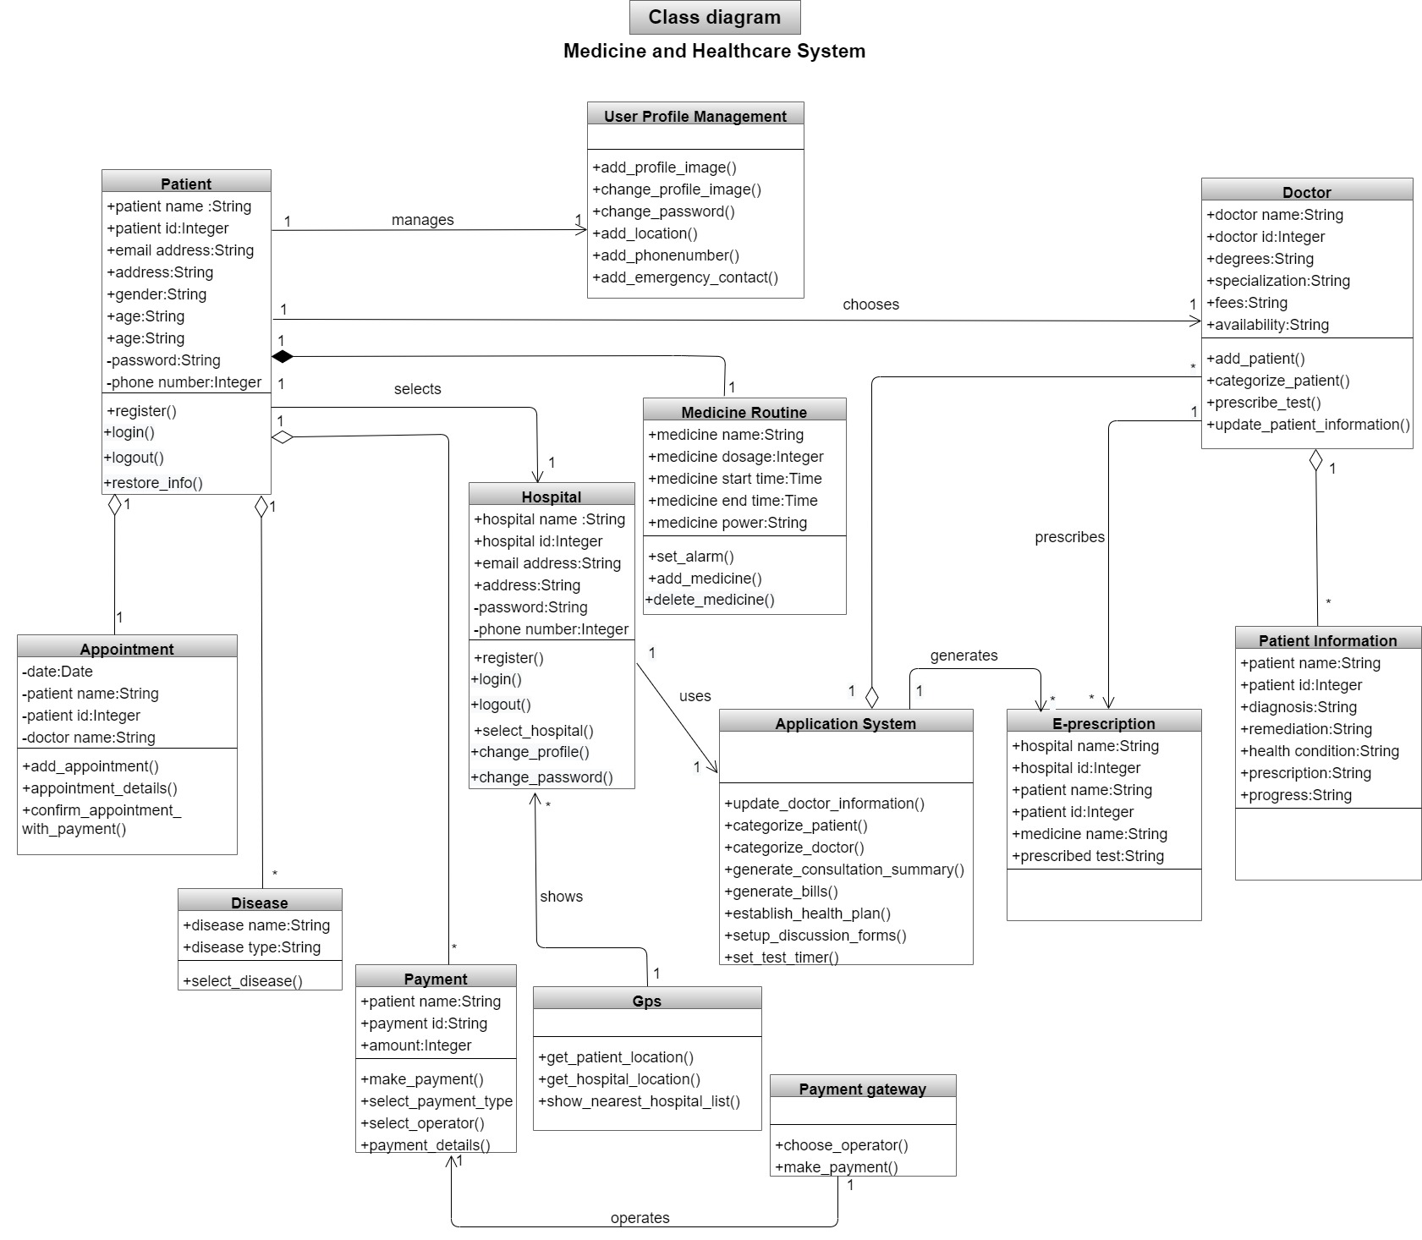

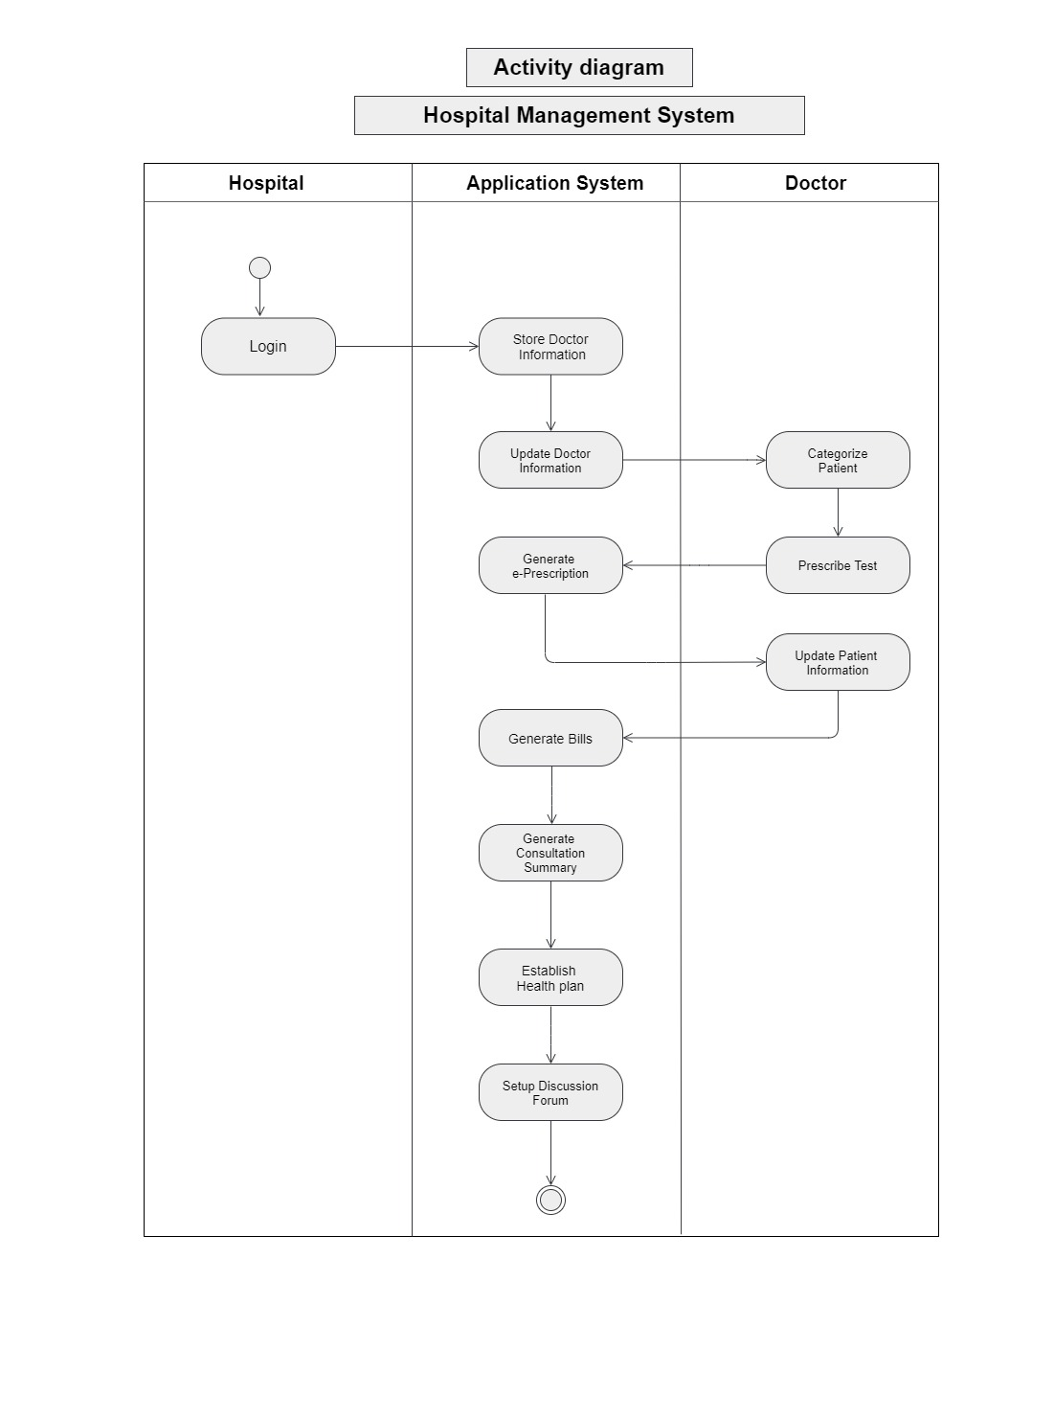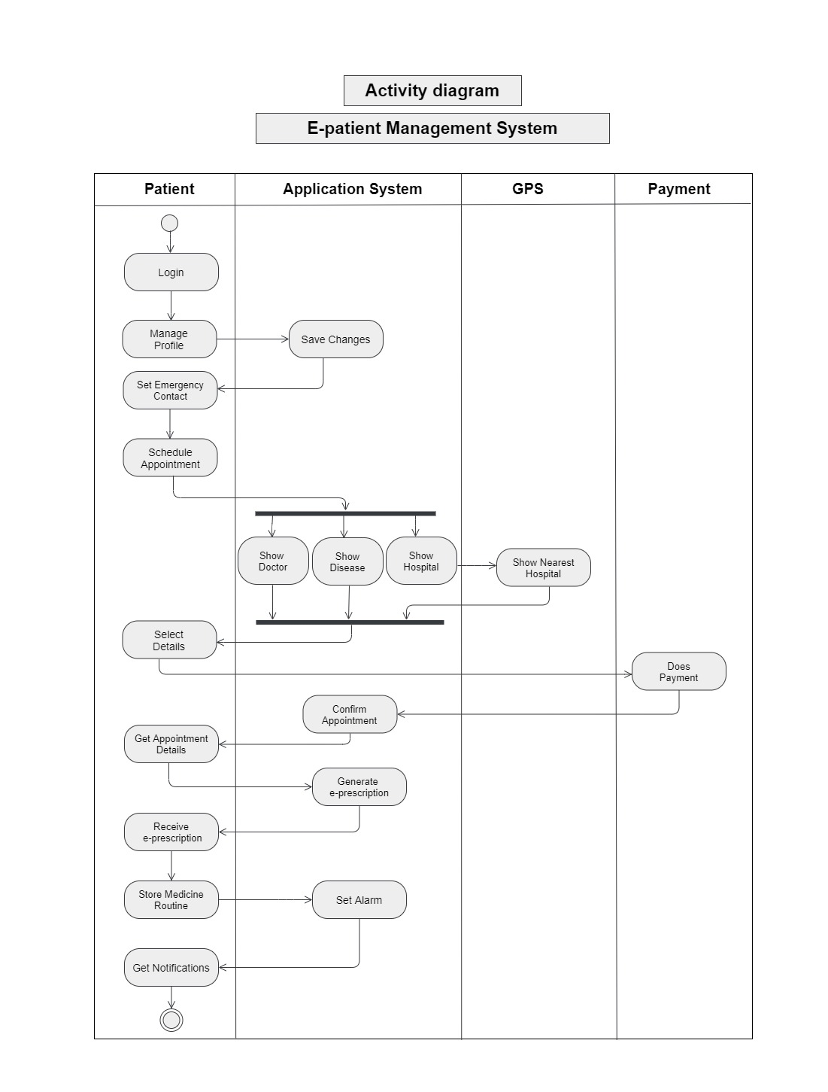

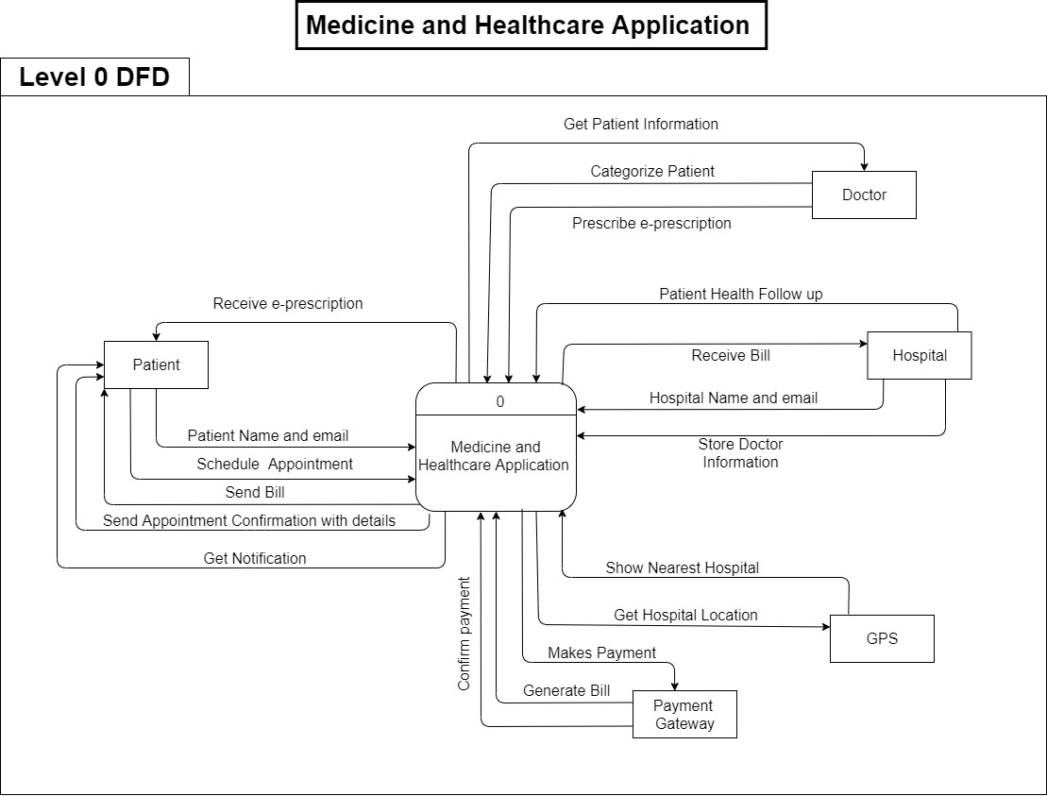

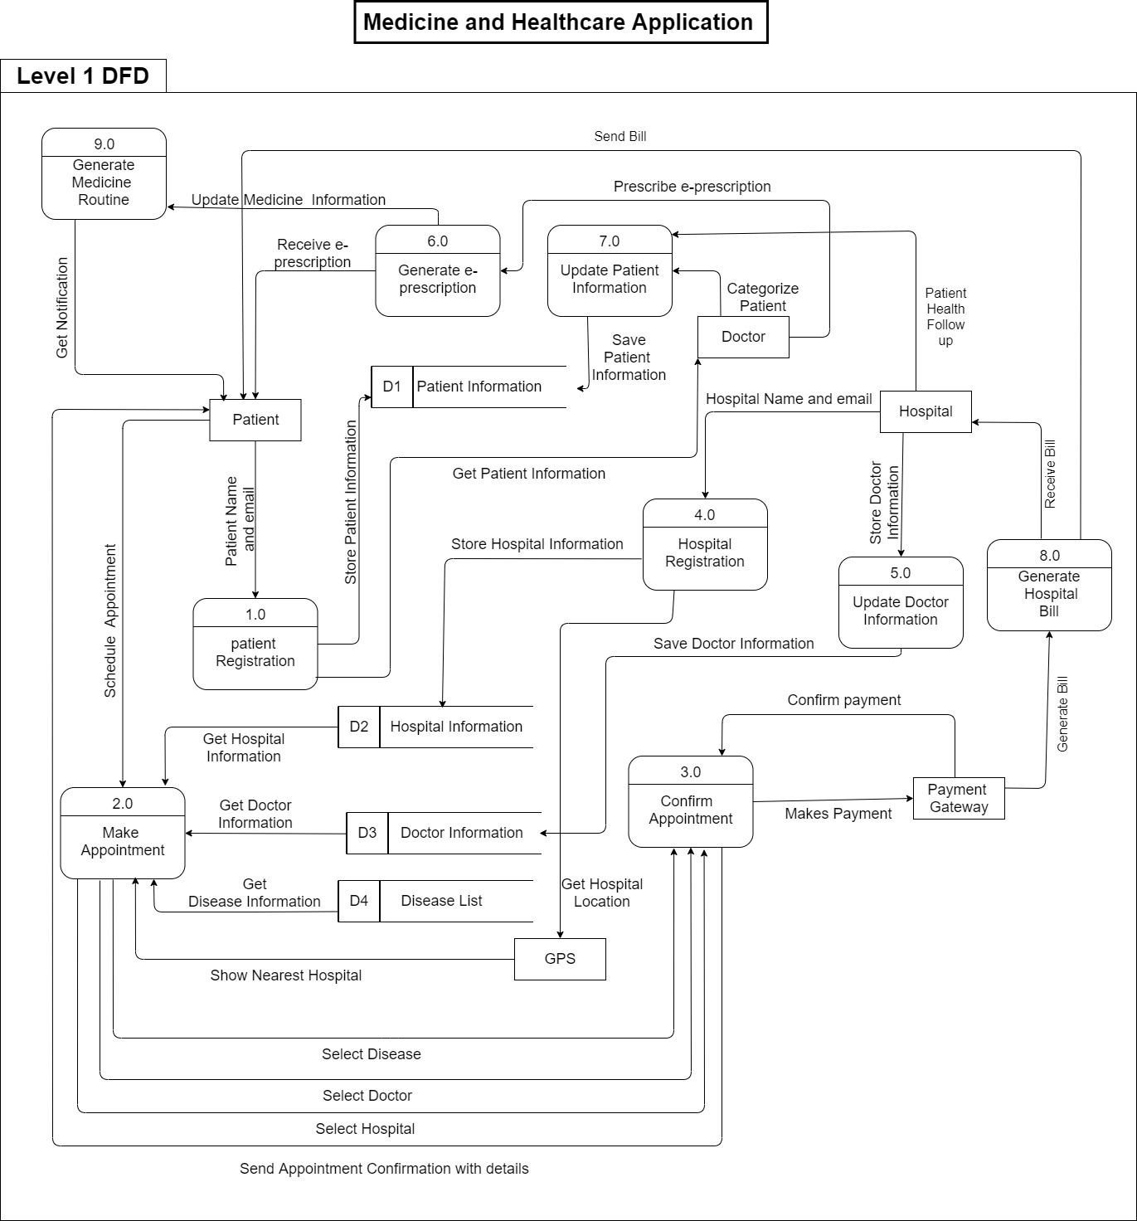

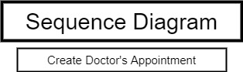

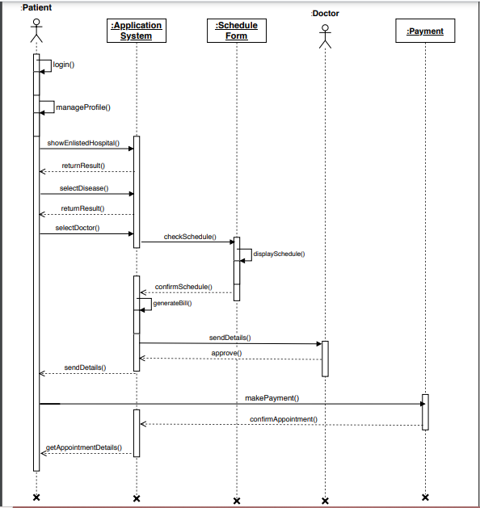

# Conclusion

* The motto of the project is to ensure telehealth facilities to all the people of the country at the cheapest rate possible redudcing hassle of the traffic jam, provide immediate medical support and thus save lives.